**IoT AgriTech**

|  |  |
| --- | --- |
| **COLLEGE** | MAHARAJA SURAJMAL INSTITUTE OF TECHNOLOGY |
| **GUIDE** | KAVITA SHEORAN |
| **COLLEGE STUDENTS** | AABHAAS SIKKA, ISHIKA PUNCHARIYA, ADARSH GOYAL, ISHITA KAPOOR |
| **SCHOOL STUDENTS** | CHARU, MEENU |
| **SCHOOL** | G.S.K.V Amalwas School, Jwalapuri, New Delhi |

**ABSTRACT:**

IoT AgriTech introduces a forward-thinking IoT project designed to revolutionize water management in both rural and urban landscapes. Leveraging cutting-edge technology, including soil moisture sensors, humidity and temperature sensors, and bidirectional water pumps, the system ensures precise and resource-efficient irrigation.

The core functionality involves continuous monitoring of soil moisture levels. When moisture falls below optimal levels, the system activates a reservoir-linked water pump, delivering water directly to the plant. Conversely, in cases of excess moisture, the system efficiently redirects water back to the reservoir, preventing over-irrigation.

This adaptable system finds application in diverse settings. In rural areas, it optimizes crop irrigation, conserving water and enhancing agricultural productivity. In urban environments, it promotes sustainable gardening by reducing water wastage.

Designed for the future, the system anticipates the integration of a soil nutrient sensor. This enhancement will enable users to monitor soil nutrient levels, ensuring plants receive essential nutrients for healthy growth.

**KEYWORDS:**

IoT, agriculture, technology, soil, moisture, over-irrigation, sensors, plants, pumps, farmers, crops, smart system, water management, humidity, temperature, light, water, nutrients.

**INTRODUCTION:**

Imagine a system that helps plants get just the right amount of water they need, using smart technology. Our project, the “IoT AgriTech”, does just that! We're using special sensors and clever pumps to make sure plants in farms and gardens get enough water without wasting any. This smart system works in both rural areas, where farmers grow crops, and in cities, where people have gardens.

We're using high-tech gadgets like sensors to keep an eye on how wet or dry the soil is. When the soil is too dry, our system automatically gives the plants a drink by pumping water to them. And if there's too much water, it cleverly pumps the extra water away to avoid drowning the plants.

Our project is like a superhero for plants, making sure they grow strong and healthy. We're also thinking about the future by planning to add a special sensor that will help us know if the soil has all the right nutrients for the plants. This way, we can take care of our plants and make sure we're not using too much water – it's like a win-win for plants and the environment!

**COMPONENTS:**

***ESP32***

***Temperature and humidity sensor***

The DHT-11 is a widely used digital temperature and humidity sensor that is commonly employed in various electronic projects and applications. The DHT-11 sensor is known for its simplicity, affordability, and ease of use.

Typically, using the DHT-11 involves connecting it to a microcontroller, reading the digital signal, and then converting the obtained data into temperature and humidity values. This sensor is commonly utilized in weather stations, environmental monitoring systems, and various DIY projects where monitoring temperature and humidity is essential.

*Specification:*

* Operating Voltage: 3 - 5V
* Max Operating Current: 3 - 2.5mA Max
* Temperature Range: 0-50°C / ±2°C
* Humidity Range: 20-80% / 5%
* Sampling Rate: 1 Hz (making every second)
* Advantage: Low cost
* Resolution: Humidity: 1%, Temperature: 1%

The DHT11 sensors typically necessitate an external 10K pull-up resistor on the output pin to facilitate effective communication with an Arduino. However, it's noteworthy that the module itself is equipped with an integrated pull-up resistor, obviating the need for an additional one.

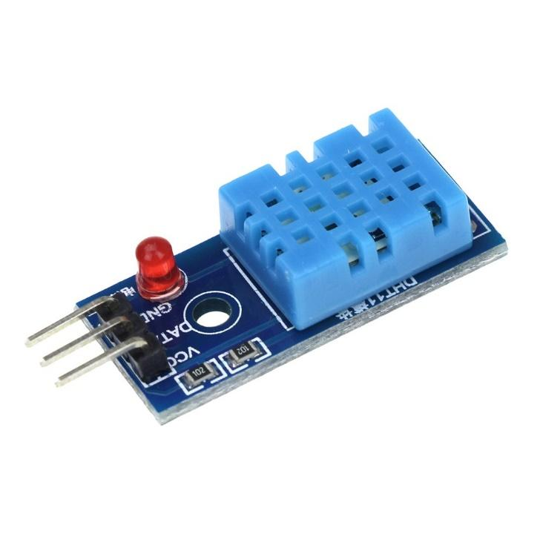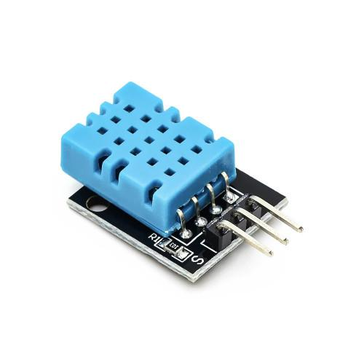Additionally, the module comes with a decoupling capacitor designed to filter power supply noise, enhancing the overall stability and reliability of the sensor's performance.

***Soil moisture sensor***

Caring for houseplants can be challenging, especially when it comes to remembering to water them regularly. Fortunately, soil moisture sensors come to the rescue, helping us keep track of our plant's hydration needs and ultimately extending their lifespan.

However, many affordable soil moisture sensors employ a resistive style, featuring two prongs that measure water content in the soil based on conductivity. While effective initially, these sensors tend to rust over time, even if gold-plated. The rusting process interferes with accurate readings, requiring constant code adjustments. Moreover, they may not perform well in loose soil.

Enter capacitive soil moisture sensors, a superior alternative. These sensors operate on capacitive measurement, offering distinct advantages over their resistive counterparts. With just one probe and no exposed metal prone to rusting, capacitive sensors provide more reliable readings. Importantly, they avoid introducing electricity into the soil, ensuring the well-being of your plants. This innovation presents a more efficient and plant-friendly solution for monitoring soil moisture levels.

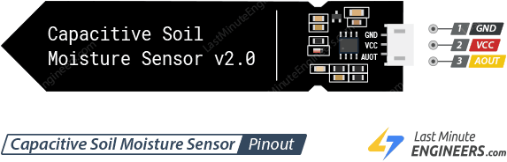

*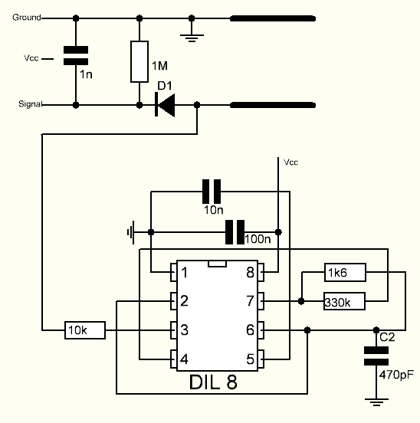Specifications: -*

* Operating Voltage: 3.3v – 5.5v DC
* Output Voltage: 0 – 3v DC
* Operating Current: 5mA
* Interface: PH2.0 – 3P
* Modes: AP, STA, AP+STA
* Output Signal: Analog Signal
* Supporting Interface: 3-Pin Gravity sensor

***Light sensor***

A light sensor is a crucial electronic component that detects and measures the intensity of ambient light in its surroundings. This device utilizes various technologies, such as photodiodes or phototransistors, to convert light energy into an electrical signal. Light sensors play a vital role in numerous applications, including automatic brightness control in displays, outdoor lighting systems, and environmental monitoring. These sensors are instrumental in optimizing energy efficiency and enhancing the performance of devices by adapting to changing light conditions. Their versatility makes them indispensable in diverse fields, from consumer electronics to industrial automation.

*Specifications:*

* Operating Voltage: 2.4 – 3.6V
* Operating Current: 0.12mA
* Communication Protocol: I2C
* Temperature: -40°C to 85°C
* Clock frequency: 400kHz
* Range: -1 – 65535 LUX
* Light Noise Rejection-Function: 50Hz/60Hz
* 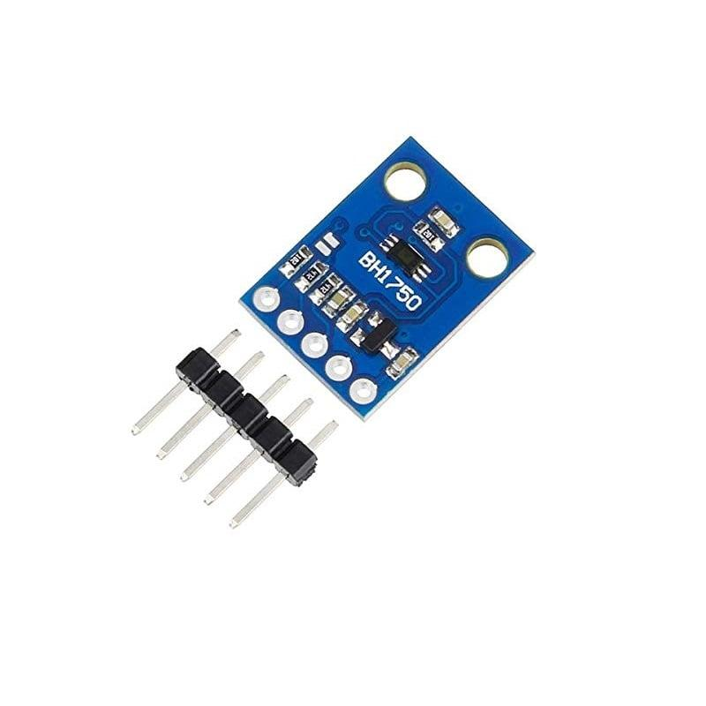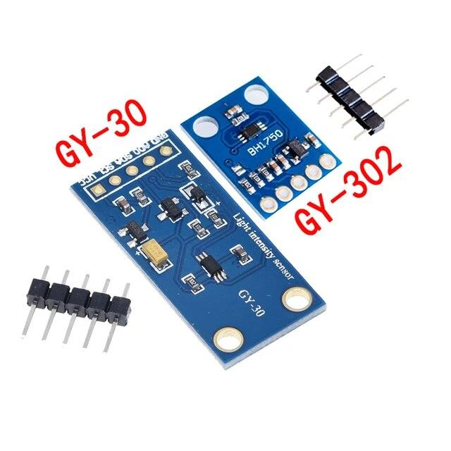Minimum I2C reference voltage: 1.65V

**BH1750**

The BH1750 serves as a Digital Ambient light sensor, effortlessly interfacing with microcontrollers through the I2C communication protocol. Known for its low power consumption, this sensor utilizes a photodiode with a PN Junction to generate electron-hole pairs in the depletion region when exposed to light. The resulting electric charge, proportional to light intensity, is transformed into voltage by an Op-Amp. This efficient conversion mechanism facilitates precise light intensity measurements in various applications. This IC is best suited to get the ambient light data in mobile phones to manipulate the screen brightness based on the environment lighting. This sensor can accurately measure the LUX value of light up to 65535.

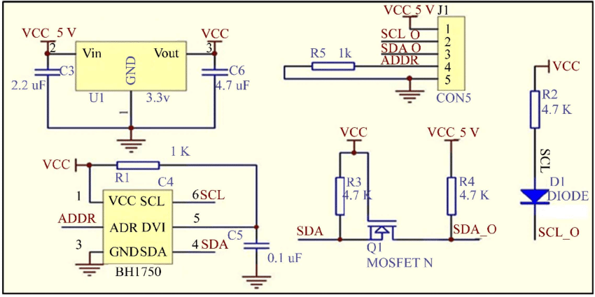

***Two-way pump***

***Water reservoir***

***Nutrient sensor (in future)***

**METHODOLOGY:**

***System Design***

Define the overall architecture and components of the Smart Irrigation System.

Identify the specific requirements for soil moisture sensors, humidity and temperature sensors, bidirectional water pumps, and the ESP32 controller.

***Sensor Integration***

Integrate soil moisture sensors to continuously monitor soil moisture levels.

Incorporate humidity and temperature sensors for comprehensive environmental data collection.

***Controller Configuration***

Set up and configure the ESP32 controller to receive, process, and transmit sensor data.

Establish communication protocols for seamless operation between sensors and the controller.

***Decision Logic Development***

Develop decision-making algorithms within the ESP32 controller.

Define the conditions for activating bidirectional water pumps based on soil moisture thresholds.

***Bidirectional Water Pump Setup***

Configure bidirectional water pumps to enable precise water flow in both irrigation and excess water removal modes.

Test and optimize pump performance for efficiency and reliability.

***Reservoir Connection and Pipe Installation***

Establish a connection between the water pump and the reservoir using water pipes.

Ensure proper water transport from the reservoir to the plant and back.

***IoT Integration***

Implement IoT capabilities to enable remote monitoring and control.

Develop a user interface for mobile devices and computers to adjust irrigation settings and receive real-time updates.

***Versatility Testing***

Conduct tests to ensure the system's adaptability to both rural and urban settings.

Evaluate performance in different environmental conditions.

***Future-Ready Design***

Plan and prepare the system for the potential integration of a soil nutrient sensor.

Design the system to accommodate additional components for future enhancements.

***Field Testing and Optimization***

Conduct field tests in both rural and urban environments to validate system performance.

Optimize algorithms and settings based on real-world feedback.

***Documentation and User Guidelines***

Prepare comprehensive documentation outlining system components, installation procedures, and troubleshooting guidelines.

Develop user-friendly guidelines for effective system utilization.

***Feedback Collection and Iterative Improvements***

Collect feedback from users and stakeholders.

Implement iterative improvements based on feedback to enhance system efficiency and user experience.

This methodology ensures a systematic and iterative approach to developing, testing, and refining the Smart Irrigation System, emphasizing adaptability, efficiency, and user-friendliness.

**CONSTRUCTION**

The IoT AgriTech project construction unfolds in a systematic manner, starting with the establishment of foundational infrastructure, including servers, databases, and networking components. This creates a robust backbone essential for subsequent stages. Sensor deployment follows, strategically placing soil, weather, and crop sensors across the agricultural area with a focus on precise calibration for accurate data collection.

The heart of the construction lies in developing the central IoT platform, serving as the nerve center for real-time data processes and storage. Simultaneously, a secure communication network is established to ensure seamless data transfer, with special emphasis on user privacy through encryption protocols. The user interface is designed for accessibility, allowing farmers remote control and monitoring via mobile devices or computers.

Data analytics integration enhances the system's intelligence, providing valuable insights from the collected data. Decision support systems are crafted to offer tailored recommendations for farmers, contributing to informed decision-making. Field testing validates the accuracy of sensor data, with calibration as needed to ensure precision in monitoring soil and crop conditions.

The system is designed with scalability in mind, accommodating future sensor additions and technological advancements. Comprehensive documentation is created to guide users through system setup and maintenance, complemented by user training sessions. The construction process concludes with iterative enhancements based on user feedback, ensuring a continuous improvement cycle for system functionality and user experience. This streamlined approach emphasizes the seamless integration of advanced technologies into agricultural practices.

**WORKING**

**COMPARATIVE STUDY**

**SOCIAL IMPACT**

The IoT AgriTech project brings about significant social impacts by revolutionizing traditional agricultural practices and fostering sustainable farming. Here are key social benefits:

***Increased Agricultural Productivity***

The implementation of advanced technologies helps farmers optimize crop management, leading to increased agricultural productivity. This, in turn, contributes to food security and economic stability within local communities.

***Water Conservation***

The precise monitoring and control features of the system aid in efficient water usage, reducing the overall water footprint of agricultural activities. This is particularly crucial in regions facing water scarcity, promoting responsible water management practices.

***Empowering Farmers***

By providing farmers with real-time data, remote monitoring, and decision support systems, the project empowers them to make informed decisions about their crops. This empowerment enhances their resilience to environmental challenges and market dynamics.

***Sustainable Agriculture Practices***

The integration of IoT technologies encourages the adoption of sustainable agriculture practices. Reduced resource wastage and optimized use of inputs contribute to environmentally friendly farming methods, aligning with broader sustainability goals.

***Rural Economic Development***

Improved agricultural practices can lead to increased income for farmers, contributing to rural economic development. This, in turn, helps alleviate poverty and enhances the overall quality of life in rural communities.

***Skill Development***

The training sessions provided as part of the project contribute to skill development among farmers and agricultural workers. This knowledge transfer enhances their technological literacy, enabling them to adapt to evolving agricultural technologies.

***Community Resilience***

The project's focus on scalable and adaptable technologies enhances community resilience to external challenges, such as climate variability and market fluctuations. By equipping communities with tools for data-driven decision-making, the project aids in building resilience against uncertainties.

***Promotion of Precision Agriculture***

Precision agriculture, facilitated by the IoT AgriTech system, minimizes input wastage and maximizes yields. This approach promotes environmentally responsible farming practices, reducing the ecological impact of agriculture on surrounding ecosystems.

***Technology Adoption in Rural Areas***

The project introduces and encourages the adoption of advanced technologies in traditionally underserved rural areas. This bridges the technological gap between urban and rural communities, fostering digital inclusion and connectivity.

***Community Collaboration***

The sharing of data and insights among farmers through the system promotes a sense of community collaboration. Farmers can learn from each other's experiences, share best practices, and collectively work towards sustainable agricultural development.

In summary, the IoT AgriTech project goes beyond technological innovation, positively impacting the social fabric of communities by promoting sustainable practices, enhancing economic opportunities, and empowering farmers with the tools they need for resilient and efficient agriculture.

**SALIENT FEATURES**

The IoT AgriTech project boasts several salient features that collectively contribute to its innovative and transformative nature:

***Real-Time Monitoring***

Utilizes advanced sensors for real-time monitoring of soil conditions, weather parameters, and crop health, providing instant insights to farmers.

***Precision Agriculture***

Implements precision agriculture techniques to optimize resource usage, including water, fertilizers, and pesticides, leading to increased crop yields and reduced environmental impact.

***Decision Support Systems***

Incorporates intelligent decision support systems that analyze data and generate actionable recommendations for farmers, aiding in informed and strategic decision-making.

***Remote Control and Monitoring***

Empowers farmers with a user-friendly interface accessible through mobile devices or computers, enabling remote monitoring and control of agricultural processes.

***Scalability and Future-Ready Design***

Designed with scalability in mind, accommodating additional sensors and technological advancements to ensure adaptability to evolving agricultural needs.

***Community Collaboration***

Encourages the sharing of data and best practices among farmers, fostering a sense of community collaboration and collective learning.

***Water Use Efficiency***

Focuses on optimizing water usage through precise irrigation techniques, contributing to water conservation and sustainable agricultural water management.

***Resource Optimization***

Maximizes the efficiency of resource usage, minimizing input wastage and reducing overall costs for farmers.

***Environmental Sustainability***

Promotes environmentally responsible farming practices, aligning with broader sustainability goals and minimizing the ecological footprint of agriculture.

***Technology Adoption in Rural Areas***

Bridges the digital divide by introducing and encouraging the adoption of advanced technologies in traditionally underserved rural areas, promoting technological literacy.

***Iterative Improvement***

Embraces an iterative approach, gathering feedback from users to continuously enhance system functionality, ensuring responsiveness to user needs.

***Training and Skill Development***

Conducts training sessions to empower farmers and agricultural workers with the skills needed to effectively utilize the IoT AgriTech system.

**BUSINESS PLAN**

**COST OF PROJECT**

**EXPECTED OUTCOMES**

The IoT AgriTech project is anticipated to yield a range of positive outcomes, contributing to enhanced agricultural practices, sustainability, and socio-economic development. Here are the expected outcomes:

***Increased Crop Yields***

The implementation of precision agriculture through real-time monitoring and data-driven decision-making is expected to lead to increased crop yields. Farmers can optimize irrigation, fertilization, and other inputs, maximizing the productivity of their fields.

***Water Use Efficiency***

The project aims to optimize water usage by providing accurate insights into soil moisture levels. This is expected to result in improved water use efficiency, crucial for regions facing water scarcity, and contribute to sustainable agricultural water management.

***Resource Optimization***

By leveraging IoT technologies, farmers can optimize the use of resources such as fertilizers and pesticides. This not only reduces costs for farmers but also minimizes the environmental impact associated with excessive use of agrochemicals.

***Cost Reduction for Farmers***

Through efficient resource utilization, remote monitoring, and informed decision-making, the project is expected to contribute to overall cost reduction for farmers. This includes savings on water, fertilizers, and energy.

***Improved Livelihoods***

Increased agricultural productivity and cost savings are anticipated to positively impact the livelihoods of farmers. Higher yields and reduced costs can lead to improved economic conditions for farming communities.

***Environmental Sustainability***

The adoption of precision agriculture practices facilitated by the project is expected to contribute to environmental sustainability. By minimizing resource wastage and reducing the ecological footprint of farming activities, the project aligns with sustainable agricultural practices.

***Enhanced Farmer Resilience***

Empowering farmers with real-time data and decision support systems enhances their resilience to environmental challenges, market fluctuations, and other uncertainties. Informed decision-making contributes to the adaptability and resilience of farming communities.

***Technology Adoption in Agriculture***

The project is expected to promote the widespread adoption of advanced technologies in agriculture, bridging the digital divide between urban and rural areas. This fosters technological literacy and connectivity in traditionally underserved agricultural communities.

***Community Collaboration***

The sharing of data and insights among farmers through the IoT AgriTech system is expected to foster a sense of community collaboration. Farmers can learn from each other's experiences, share best practices, and collectively work towards sustainable agricultural development.

***Data-Driven Agriculture Policies***

Aggregated data from the project has the potential to inform data-driven agriculture policies at regional or national levels. Policymakers can use the insights to formulate strategies that support sustainable agriculture and rural development.

***Increased Food Security***

Through improved agricultural productivity and resource efficiency, the project contributes to increased food security. This is particularly impactful in regions where agriculture is a primary source of livelihood.

***Knowledge Transfer and Skill Development***

The training sessions provided as part of the project contribute to knowledge transfer and skill development among farmers. This knowledge enhances their ability to leverage technology for improved agricultural practices.

In summary, the expected outcomes of the IoT AgriTech project encompass a spectrum of positive impacts, ranging from economic benefits for farmers to environmental sustainability and enhanced resilience within farming communities.

**CONCLUSION**

In conclusion, the IoT AgriTech project stands as a beacon of innovation in agriculture, promising transformative benefits for farmers and the environment alike. By seamlessly integrating cutting-edge technologies, the project not only enhances crop yields and resource efficiency but also empowers farmers with real-time data and decision support. The anticipated outcomes, ranging from economic upliftment to environmental sustainability, underscore the project's potential to redefine traditional farming practices. As a catalyst for community collaboration and knowledge transfer, the project not only addresses current agricultural challenges but also positions itself as a scalable and adaptable solution for a sustainable and resilient future in agriculture.